**Ideation Phase Empathize & Discover**

|  |  |
| --- | --- |
| Date | 23 November 2023 |
| Team ID | E18449089FCOE099F7543153EOEADF4 |
| Project Name | Transparent education data management |
| Maximum Marks | 4 Marks |

**Empathy Map Canvas:**

Print cost savings through reduction in re point.

For managing the tracking of bus position and operational data.

privacy and security of personal information.

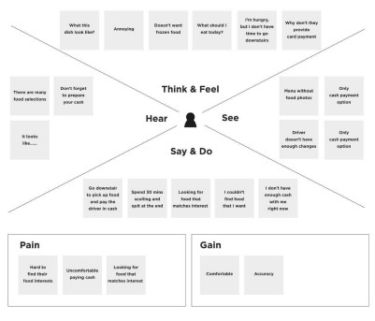

Education service registration will be support.

Potential to deliver data management for other local authorities in revenue stream NCC .

user-friendly experience for managing identity on the blockchain.

Opportunities to enhance real time information at marginal cost.

compliance with standards.

tools for secure contract development.

clear instructions, and assurance of data security.

transparent communication from developers.

More accurate data improves reliability of education.

Norfolk county council will be able to meet the department for EBSR.

**Pain:**

* This paper presents the design.
* Implementation of a blockchain system, purposed for information verification .
* Data security.

**Gain:**

* Re -allocation of staff.
* Reduction in premium rate charge for the real time system data upload.
* Savings in material and printing costs due to re-work of timetables wayside.